**Black Box Calculation**

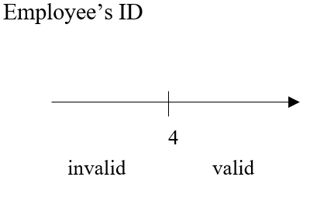

* ***EP***
* <= 4
* >= 4
* ***Test Values***
* 4
* 3
* 5
* ***Boundary Values***
* 3,4,5